Global Call for Performers to participate in Dance Festival Malta's Community Performance
Urban Symphony

A 4-day workshop resulting in an outdoor performance in Valletta The call is for: Dancers, Movers and Musicians who move

Dates/Times:

The workshops will take place on 27, 28, 29, 30th July 2023 from 13:00-17:00. Attendance for all workshop days is mandatory. The outdoor performance will be held on the last day, 30th of July at 7.00 pm in Freedom Square, City Gate Valletta.

Location for the creative process: Spazju Kreattiv, Valletta. Fee: Free

Project:
Moving Communities in Urban Spaces will be led by Julienne Schembri (Malta) and Maya Felixbrot (Israel). This community project will investigate the continuum of Harmony and Disharmony in the urban environment of Valletta, and question how the movement of the collective - the performing community as well as the people in the city - connect and engage with the city. Taking the symphonic structure as a container, the community collective will experiment with the resonance of the urban environment in Valletta. The performative language will comprise movement, voice and musical instruments that take inspiration from the rhythms, architectural character, and the visual and sonic structures in Valletta. The score, comprising of movement and sound, will be curated around the musical symphony and the artists will look to structures used in the Maltese Għana to support the phrasing of the group’s movement in body and sound. The lead artists will amplify the already playing symphony in the city and the spaces they will perform; the structure of the fountain, the movement of the water, the existing movement of the public in the city, the sonic textures we hear in these locations, the collective memories and the visual harmonies.

What we are looking for:
We are looking for up to 20 movers (16+) from all backgrounds to join this workshop project. Individuals should have experience in dance and/or movement and be open to delve into a process of exploration and experimentation.
To apply, you would need to send us:
- 1-page CV / 250-word bio,
- A video showing your skills and interests as a performer (max 3 minutes), and
- A short paragraph stating why you would like to be part in this project.
- The deadline for application is 20th May 2023. Email application to be sent
to juschembri@gmail.com

Julienne Schembri (Malta)
I am a performer, movement and dance practitioner, and artist in community. I graduated MA from The London Contemporary Dance School. Independently, I work as a somatic movement educator through the Laban Bartenieff Movement System, to create communities of people moving together. I’m co-founder of Dance Beyond Borders whose intention is to develop socially engaged events that create spaces of welcome and integration. As a collective, we have a community practice and produce Refugee Week Malta, the local edition of the international celebration.
https://www.dancebeyondborders.org/

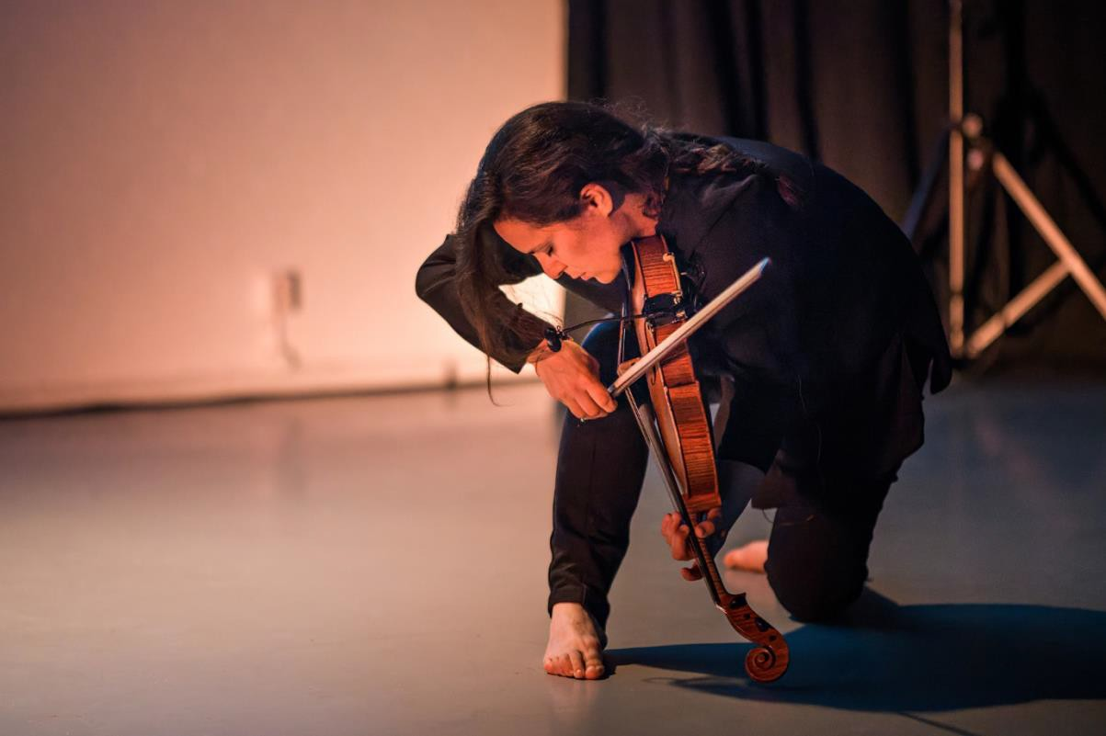

Maya Felixbrot (Israel)
I am a musician, Violist, and composer. I graduated with an MA from Het Koninklijk Conservatorium, The Hague. My speciality is to reconnect sound and music, through music and the Laban Bartenieff Movement System, as a whole: a woven fabric in which the two create new territories. Games, improvisation, discipline, and their multiplicity are for me a means as well as a meaning. I am also a Certified Movement Analyst and movement educator. I am the co-curator of Screen Dive, co-founder and artistic director of Moving Strings, and a member of the duos Zvov and NO HORNS. My teaching and coaching span over 20 years of experience. Website: www.pninax.com

